# 23RD ANNUAL NARCOTICS TRAINING CONFERENCE

**LOUISIANA NARCOTICS OFFICERS ASSOCIATION**

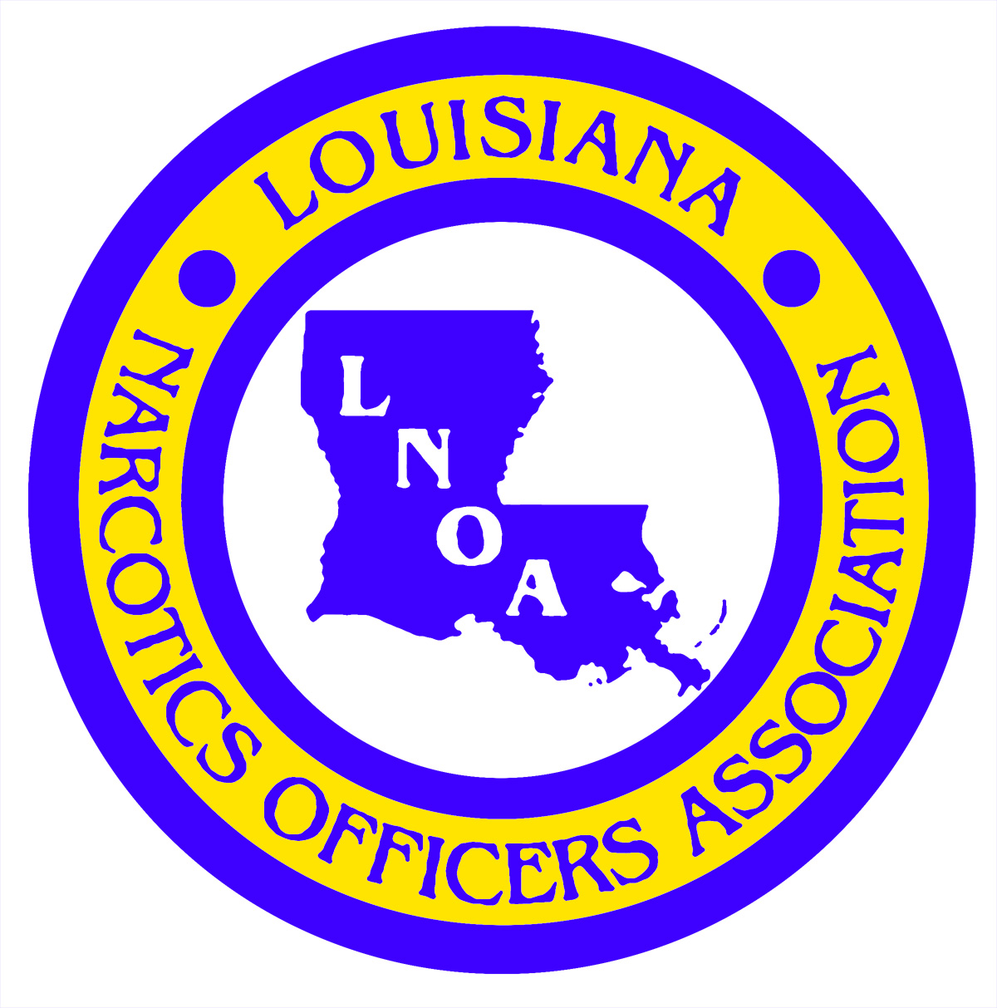

# 2016 CONFERENCE

# REGISTRATION FORM

**NAME:**

(Last) (First)

**DOB:** ________________________________

(Needed for Life Insurance Policy)

**AGENCY:**

______________________________________

**MAILING ADDRESS:**

______________________________________

(Street Address/P.O. Box)

______________________________________

(City) (State) (Zip Code)

**CONTACT PHONE NUMBERS:**

(_____)_______________________________

(Office)

(_____)_______________________________

(Cellular)

(_____)_______________________________

(Fax)

**EMAIL ADDRESS:**

_____________________________________

**PARISH:**_____________________________

**REGION:**_____________________________

ASTOR CROWNE PLAZA

NEW ORLEANS, LOUISIANA

August 15, 2016

Thru

August 19, 2016

**The Louisiana Narcotics Officers Association will be hosting our Annual Training Conference in New Orleans, Louisiana beginning with registration in the evening on Monday, August 15, 2016 (5:00pm-6:30pm) and again in the morning on Tuesday, August 16, 2016 (9:00am-10:30am). At the conclusion of Tuesday’s registration, a business meeting to be attended by all conference attendees/active LNOA members will be held from 10:30am-Noon. Classes will begin Tuesday, August 16, 2016 at 1:30pm and will conclude Friday, August 29, 2016 at Noon.**

**You must present your law enforcement commission during Conference Registration**

**\*\*\*\*\*\***

**CLASSES ARE STILL BEING SCHEDULED**

**\*\*\*\*\*\***

AS SOON AS SCHEDULING OF

CLASSES AND SPEAKERS ARE COMPLETED,

NEW BROCHURES WILL BE SENT OUT TO INCLUDE

THE INFORMATION

**\*\*\*\*\*\***

**REGISTRATION AT THE ASTOR CROWNE PLAZA AND TO ATTEND THE CONFERENCE CAN BE MADE NOW**

**\*\*\*\*\*\***

The Louisiana Narcotics Officers Association’s Annual Training Conference will be held at the Astor Crowne Plaza in New Orleans, Louisiana. A block of rooms have been reserved for LNOA conference attendees at a special rate (per day) of:

Single/Double: $ 99.00

Triple: $119.00

Quad: $139.00

Parking Charge: $ 25.00

Room reservations for conference attendees can be made by calling 877-408-9661 by July 17, 2016. Be sure to mention that you are attending the LNOA Conference to receive our special room rates.

**\*\*\*\*\*\*\*\*\*\*\*\*\*\*\*\*\*\*\*\*\*\*\*\*\*\*\*\*\*\*\***

**CONFERENCE TUITION: $140.00**

**To pre-register for the conference, complete the Registration Form and mail it along with your tuition to: LNOA – P.O. Box 2329 – West Monroe – Louisiana – 71294. The completed Registration Form can also be faxed to: Cindy Emory at (318) 397-2382 or e-mailed to:** [**cindyemory@hotmail.com**](mailto:cindyemory@hotmail.com)**. If you choose to fax or e-mail your Registration Form, payment can be made during registration at the conference. Forms of payment accepted: Cash, check, money order or credit card.**

**ASTOR CROWNE PLAZA**

**739 CANAL STREET**

**NEW ORLEANS, LOUISIANA**

**For LNOA information, contact:**

**Cindy Emory – (318) 614-7321**

[**cindyemory@hotmail.com**](mailto:cindyemory@hotmail.com)

#### 2016 LOUISIANA NARCOTICS OFFICERS ASSOCIATION ANNUAL CONFERENCE