# 26TH ANNUAL NARCOTICS TRAINING CONFERENCE

**LOUISIANA NARCOTICS OFFICERS ASSOCIATION**

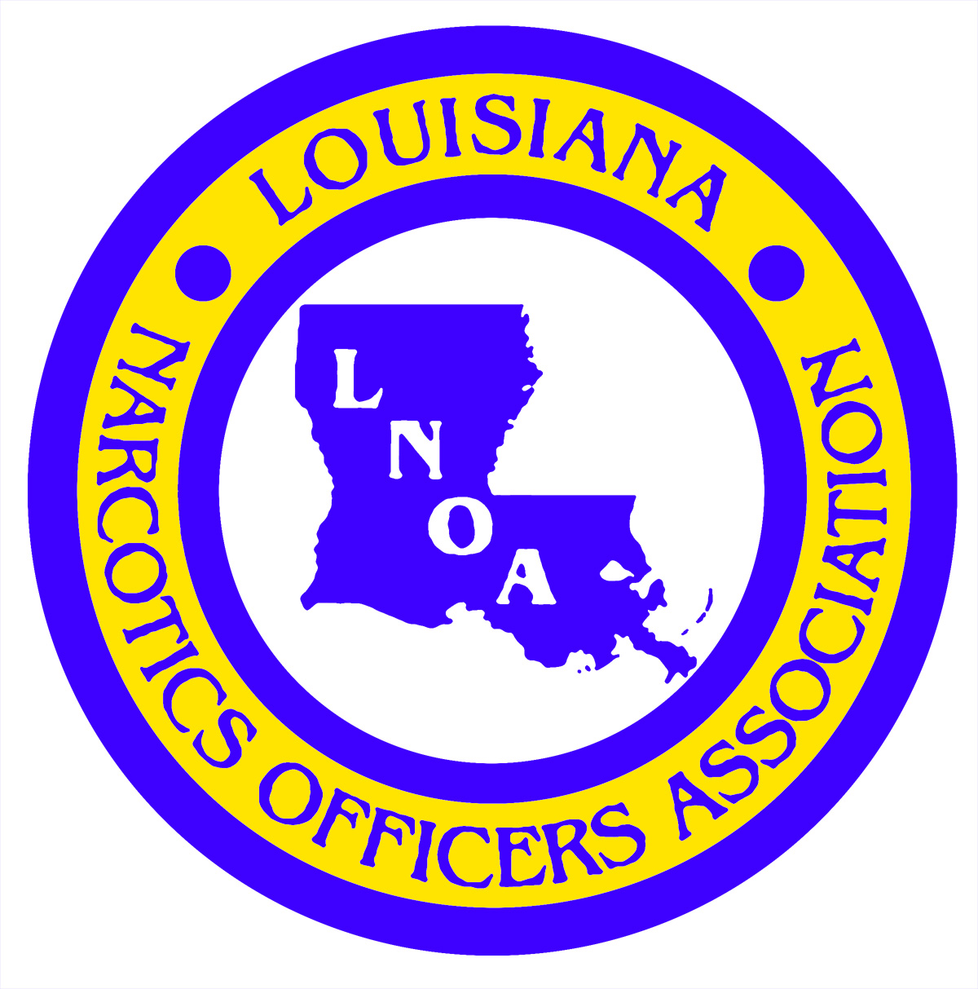

# 2019 CONFERENCE

# REGISTRATION FORM

**NAME:**

(Last) (First)

**DOB:** ________________________________

(Needed for Life Insurance Policy)

**AGENCY:**

______________________________________

**MAILING ADDRESS:**

______________________________________

(Street Address/P.O. Box)

______________________________________

(City) (State) (Zip Code)

**CONTACT PHONE NUMBERS:**

(_____)_______________________________

(Office)

(_____)_______________________________

(Cellular)

(_____)_______________________________

(Fax)

**EMAIL ADDRESS:**

_____________________________________

**PARISH:**_____________________________

**REGION:**_____________________________

ROYAL SONESTA HOTEL

NEW ORLEANS, LOUISIANA

August 5, 2019

Thru

August 9, 2019

**The Louisiana Narcotics Officers Association will be hosting our Annual Training Conference in New Orleans, Louisiana beginning with Registration in the evening on Monday, August 5th (4:00pm-5:30pm) and again in the morning on Tuesday, August 6th (9:00am-10:00am). At 10:00am on Tuesday, there will be a LNOA Business & Conference Welcome Meeting to be attended by all conference attendees. Classes will begin Tuesday (1:00pm-5:00pm) to be followed with classes scheduled for Wednesday and Thursday (9:00am-4:30pm) and concluding Friday at noon. LNOA will host a Dinner Banquet (business casual attire required) for all conference attendees Thursday at 6:00pm at the Royal Sonesta.**

**You must present your law enforcement commission during Conference Registration**

**TRAINING CLASSES**

**UNDERCOVER OPERATIONS**

**CRIMINAL PATROL**

**FENTANYL**

**SOCIAL MEDIA**

**LEGAL UPDATES**

**~ADDITIONAL CLASSES TBA~**

**CLASSES & INSTRUCTORS ARE SUBJECT TO BE CHANGED OR ADDED**

***************************************

**CONFERENCE TUITION: $150.00\***

**\*Includes LNOA Membership Dues for 2019-2020**

The Louisiana Narcotics Officers Association’s Annual Training Conference will be held at the Royal Sonesta Hotel in New Orleans, Louisiana. A block of rooms has been reserved for LNOA conference attendees at a special rate of:

**$99.00 per room/per night**

This special room rate is being offered 3 days prior to and 3 days after the conference dates. Room rates do not include applicable room (13.45%) and occupancy ($2.00) tax and Statutory Tourism Support Assessment (1.75%).

**Parking Charge: $ 20.00 per car/per night**

**Room reservations can be made by calling 855-463-3092 by July 8, 2019.** Be sure to mention that you are attending the LNOA Conference to receive our special room rates.

**Pre-register by mail: LNOA**

**P.O. Box 2329**

**West Monroe, LA 71294**

**Pre-register by fax: Cindy Emory at (318) 397-2382 or e-mail to:** [**cindyemory@hotmail.com**](mailto:cindyemory@hotmail.com)

**If you choose to fax or e-mail your Registration Form, payment can be made during registration at the conference. Forms of payment accepted: Cash, check, money order or credit card.**

**ROYAL SONESTA HOTEL**

**300 BOURBON STREET**

**NEW ORLEANS, LOUISIANA**

**For LNOA information, contact:**

**Cindy Emory – (318) 614-7321**

[**cindyemory@hotmail.com**](mailto:cindyemory@hotmail.com)

#### 2019 LOUISIANA NARCOTICS OFFICERS ASSOCIATION ANNUAL CONFERENCE